# Online Literary Management System

# Introduction

In the world of literature, novels have long captivated readers with their immersive narratives and diverse genres. With the advent of the digital age, novels have found a new platform in the form of web novels, offering a convenient and accessible way to engage with literary works. To enhance the reading experience and guide users towards their desired literary preferences, novel management systems play a crucial role.

This proposal outlines the development of an Online Literary Management System designed to empower users with the tools they need to organize their digital libraries with ease. This system will prioritize user-friendliness, flexibility, and essential functionalities, making it suitable for a wide audience.

# Problem Statement

The ever-expanding landscape of online literary content presents a challenge for users in managing their personal libraries. Existing management solutions may lack user-friendliness, require advanced technical skills, or lack essential functionalities, making them unsuitable for a wide audience. This project addresses these limitations by creating a user-centric system tailored to individual needs and preferences.

# Objectives

The Online Literary Management System aims to:

* Offer an intuitive user interface: Prioritize user-friendliness and intuitive navigation for seamless interaction.
* Implement comprehensive CRUD functionalities: Integrate Create, Read, Update, and Delete functions for effective content management.
* Enable flexible organization: Allow users to personalize their libraries through categorization, tagging, and custom sorting options.
* Ensure wide compatibility: Support various formats of online literary resources, offering a comprehensive solution.

# Methodology

This proposal outlines a novel management system employing the Spiral Methodology for continuous improvement and user-centric development. This approach allows for early risk identification and mitigation, ensuring the system evolves to meet user needs and preferences.

Key Benefits of the Spiral Methodology:

* Early Risk Mitigation: Potential problems are identified and addressed early, reducing development risks.
* User-Centered Development: Continuous feedback ensures the system aligns with user needs and preferences.
* Incremental Improvement: Features are added and improved gradually, allowing for easier testing and adaptation.
* Reduced Development Costs: Early risk mitigation and iterative development optimize resource allocation.
* Improved System Performance: Continuous feedback loops lead to ongoing improvement in user experience. [1]

System Development Activities:

* Planning: Define system requirements, user stories, and key functionalities.
* Design: Design user interface elements, create wireframes and mockups.
* Development: Implement functionalities, test for bugs and compatibility.
* Evaluation: Gather user feedback, refine features and user interface.

## Requirement Identification:

1. Study of existing systems: Analyze strengths and weaknesses of existing management solutions to identify opportunities for improvement.
2. Requirement collection: Gather user feedback through surveys and interviews to understand user needs and desired functionalities.

## Feasibility Study:

### Technical Feasibility:

The technical feasibility will be assessed in terms of the availability of appropriate technologies, software tools, and expertise. This will include researching existing open-source libraries and frameworks to maximize efficiency and development speed.

### Operational Feasibility:

The operational feasibility will consider the resources required to implement and maintain the system, including personnel, infrastructure, and operational costs. A scalable and cost-effective infrastructure will be chosen to ensure long-term sustainability.

### Economic Feasibility:

The economic feasibility will evaluate the potential benefits of the system, such as increased user engagement, improved customer satisfaction, etc.

## High-Level Design of System:

### System Flow Chart:

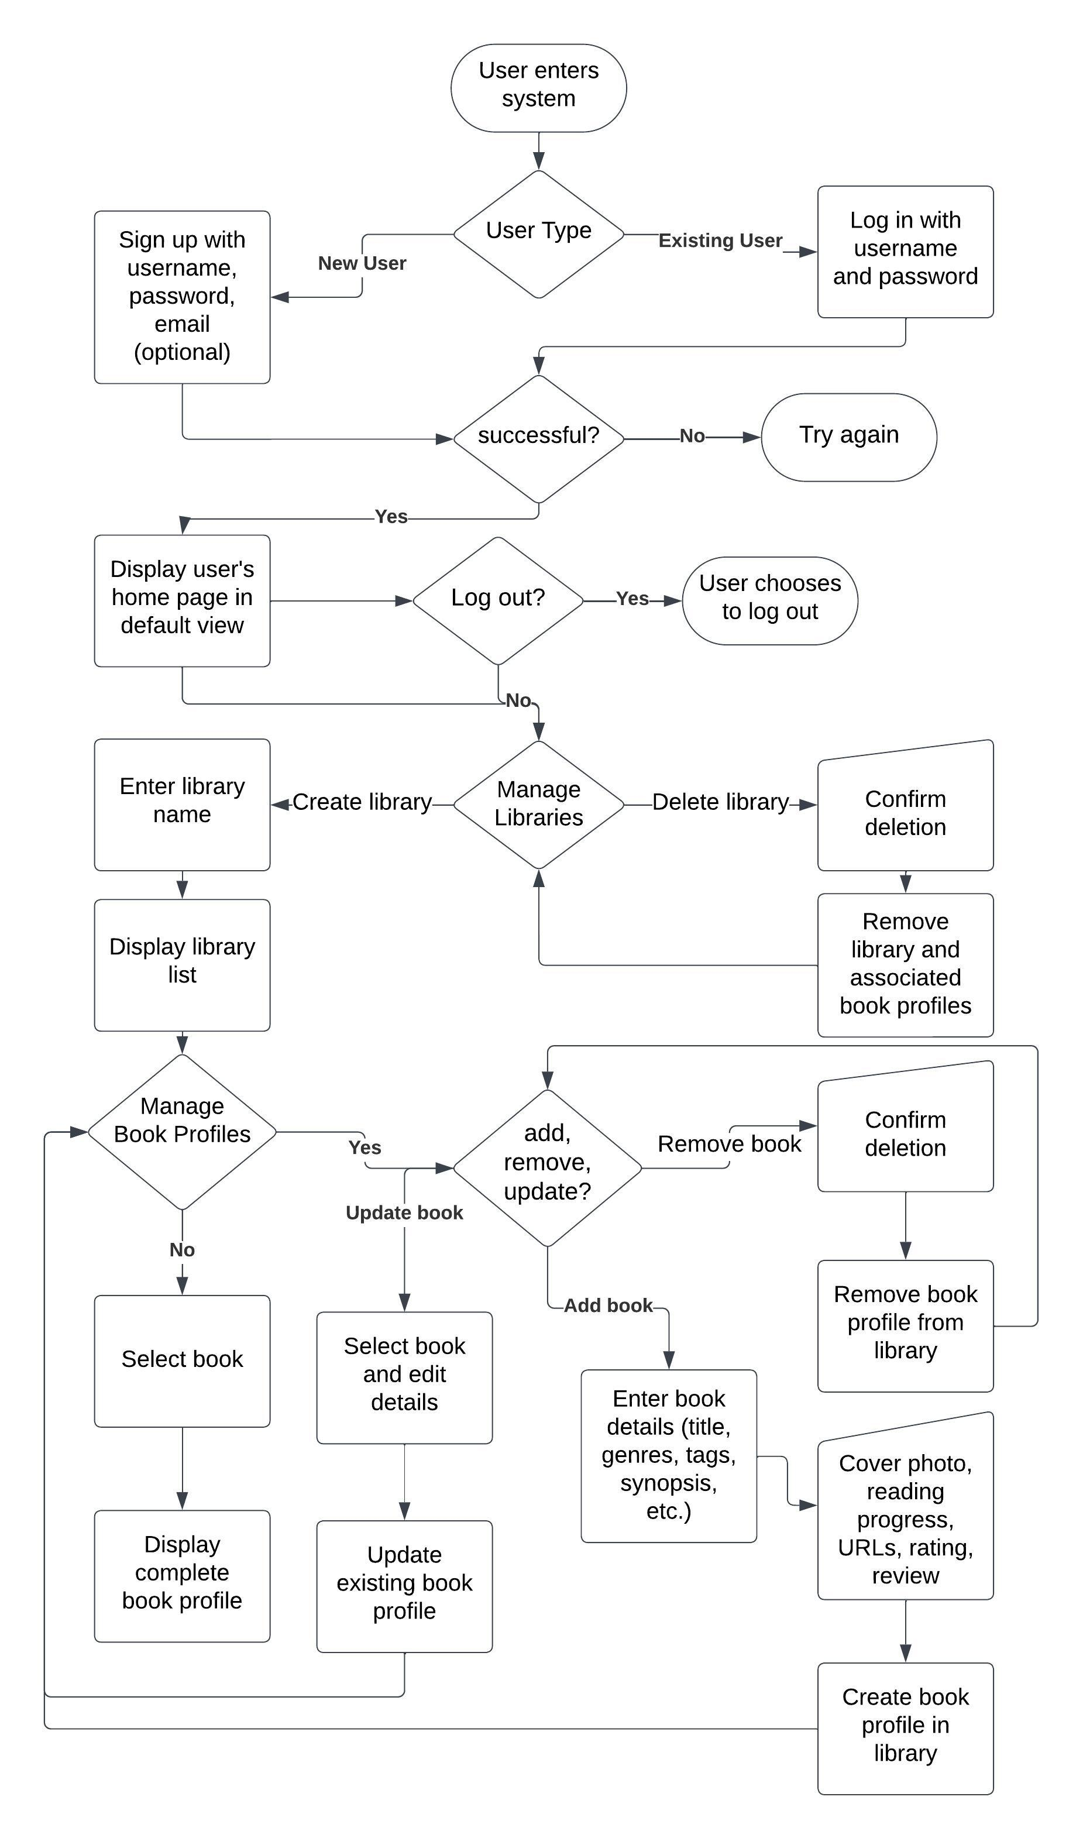

### Methodology of the Proposed System:

The system will utilize appropriate technologies and frameworks to facilitate efficient and scalable data management. This will ensure a smooth user experience across various platforms and devices.

### Working Mechanism of the Proposed System:

The proposed system will allow users to easily manage their online literary resources through a user-friendly interface. Users will be able to add, edit, delete, and categorize their literary collections, making it easy to find and organize desired content.

# Gantt Chart:

# Expected Outcome

The Online Literary Management System is expected to:

* Enhance user experience with efficient and personalized library management.
* Increase discoverability of desired literary content within personal collections.
* Demonstrate the feasibility of creating a user-centric and functionally rich system.

# References

|  |  |
| --- | --- |
| [1] | T. Contributor, "What is Spiral Model?," Tech Target, August 2019. [Online]. Available: https://www.techtarget.com/searchsoftwarequality/definition/spiral-model#:~:text=The%20spiral%20model%20is%20a,elements%20of%20the%20Waterfall%20model.. [Accessed 15 December 2023]. |
|  |  |